## Oak-Conifer Forest and Woodland (OCFW)

### General Information

### Cover Type Overview

* 125,308 acres / 50,710 hectares
* Crosswalks
  + East of the Sierra Crest
    - Regional Dominance Type 1 = Black Oak
    - Regional Dominance Type 1 = Eastside Pine, Jeffrey Pine, Ponderosa Pine
      * + Regional Dominance Type 2 = Black Oak, Canyon Live Oak, Madrone, Montane Mixed Hardwood, Scrub Oak
  + West of the Sierra Crest
    - Regional Dominance Type 1 = Black Oak, Eastside Pine, Jeffrey Pine, Ponderosa Pine
  + LandFire BpS Model: 0610300 Mediterranean California Lower Montane Black Oak-Conifer Forest and Woodland
  + Presettlement Fire Regime Type: Yellow Pine
* Ultramafic
  + This modifier is created by intersecting an ultramafic soils/geology layer with the existing vegetation layer. Where cells intersect with OCFW they are assigned to the ultramafic modifier.

### Vegetation Description

The Oak-Conifer Forest and Woodland landcover type is characterized by woodlands or forests of *Pinus ponderosa* with one or more oaks, such as *Quercus kelloggii*, *Quercus garryana*, *Quercus wislizeni*, or *Quercus chrysolepsis*. *Pseudotsuga menziesii* and other conifer species are uncommon but may co-occur, especially after long-term fire suppression (LandFire 2007a). *Pinus jeffreyi* may occur on ultramafic sites (Fitzhugh 1988). In some areas, sites are dominanted initally by oaks, which form a dense subcanopy. Eventually, and especially on locally mesic sites, conifers will form a persistent emergent canopy over the oak as a bi-layered canopy (LandFire 2007a). In other cases, characteristic species occur in a mosaic-like pattern with small pure stands of conifers interspersed with small stands of broad-leaved trees. *Q. chrysolepsis* may occur in pure stands, particularly on harsher sites. Most of the broad-leaved trees are schlerophyllous evergreen, but winter-deciduous species also occur (Anderson 1988). The understory is composed of shrubs such as *Arctostaphylos, Ceanothus, Chamaebatia, Cornus, Eriodictyon, Garrya, Prunus, Rhamnus, Ribes,* and *Toxicodendron diversilobum*. Grasses and forbs are diverse and include *Bromus, Melica, Poa, Elymus, Carex, Collinsia, Saltugilia, Iris, Lupinus, Streptanthus, Viola,* and *Pteridium aquilnum* (LandFire 2007a; Fitzhugh 1988)*.*

* **Ultramafic Modifier** *P. ponderosa* woodlands occur mainly on low-elevation ultramafics. They grow on strongly serpentinized soil, and they are in the vicinity of *P. ponderosa-Q. kelloggii* woodland that grows on deep, nonultramafic soil. While *P. ponderosa* dominates, it is associated with *Calocedrus decurrens, Pinus attentuata, Pinus lambertiana, P. sabiniana*, and *Q. chysolepis*. The shrub layer is dominated by *Arctostaphylos, Ceanothus, Eriodictyon, Heteromeles, Pickeringia*. The herb layer is a mix of sparse perennials and many annual grasses and forbs (O’Geen et al. 2007).

### Distribution

This type occurs in the valleys and lower slopes of mountainous terrain, on a variety of parent materials including granitics, metamorphic and Franciscan metasedimentary parent material and deep, well developed soils, although rocky soils are also possible. Slopes are generally steep and all aspects are included. In the northern Sierra Nevada the elevational range is 240 to 1800 m (800 to 5000 ft) (LandFire 2007a, Anderson 1988).

* **Ultramafic Modifier**  Ultramafics have been mapped at various spatial densities throughout the elevational range of the OCFW landcover type. Low to moderate elevations in ultramafic and serpentinized areas often produce soils low in essential minerals like calcium potassium, and nitrogen, and have excessive accumulations of heavy metals such as nickel and chromium. These sites vary widely in the degree of serpentinization and effects on their overlying plant communities (“CalVeg Zone 1” 2011). Note, the terms “ultramafic rock” and “serpentine” are broad terms used to describe a number of different but related rock types, including serpentinite, peridotite, dunite, pyroxenite, talc and soapstone, among others (O’Geen et al. 2007).

**Disturbances**

### Wildfire

Wildfires are common and frequent; mortality depends on vegetation vulnerability and wildfire intensity. Low severity fires kill small trees and consume above-ground portions of shrubs and herbs, but do not kill large trees or below-ground organs of most shrubs and herbs which promptly re-sprout. High mortality fires kill large as well as small trees, and may kill many of the shrubs and herbs as well. Fire kills the above-ground portions of the shrubs and herbs, but most shrubs and herbs promptly resprout from surviving below-ground organs. Wildfires may trigger transitions between developmental condition classes.

OCFW sites are fire-adapted and had frequent, low severity surface fires prior to fire exclusion in the late nineteenth century. Historically, fire return intervals (FRIs) in *P. ponderosa*-*Q. kelloggii* forests increased with increasing elevation in the Sierra Nevada, with a tendency towards shorter mean FRIs (5-15 years) on dry, west- and south-facing slopes and longer FRIs (15-25 years) on mesic, east- and north-facing slopes. Mid-elevation forests typically had mixed-severity fires that created patchy mosaics (Fryer 2007).

Data on FRIs are available from a few review papers. According to Fryer, fire-return intervals for *P. ponderosa* forests with a *Q. kelloggii* component ranged from 6 to 22 years in the Cascade Range of southern Oregon and northern California (2007). Skinner and Chang (1996) aggregated FRIs from the Sierra Nevada and separated pre-1850 data from overall data. Their paper included a study on “Black oak-ponderosa pine” vegetation in the Central Sierra in which the median FRI was 8 years, with a minimum of 2 years and a maximum of 18 years. Another study on “canyon live oak-mixed conifer” vegetation also found evidence of frequent presettlement fire: median FRI was 11 years, with a minimum FRI of 7 years and a maximum of 33 years. Van de Water and Safford’s 2011 review paper aggregates hundreds of articles, conference proceedings, and LandFire data on fire return intervals, with an emphasis on Californian sources. The analogous presettlement fire regime for Van de Water and Safford (2011) to the YHR type is Yellow pine, which has a mean FRI of 11 years, a median of 7, a mean min of 5, and a mean max of 40.

We also include here data from the pertinent individual LandFire BpS model (2007a). LandFire’s Mediterranean California Lower Montane Black Oak-Conifer Forest and Woodland for the northern Sierra notes that historical fire frequency was 5-30 years in this type. Modelers estimate mean FRIs of 180 years for replacement fire, with a range of 100 to 300 years. For “mixed” fire, the predicted mean FRI is 50 years, with a range of 50 to 200 years. For surface fire, the predicted mean FRI is 9 years, with a range of 5 to 30 years (2007a). We recalculated these numbers using condition-specific information and using only high and low mortality fire categories, which resulted in a mean FRI of 55 years for high mortality fire, 9 years for low mortality fire, and 8 years for any fire.

* **Ultramafic Modifier** The LandFire model for Klamath-Siskiyou Lower Montane Serpentine Mixed Conifer Woodland (2007b) reports an overall mean FRI of 10 years. Low mortality surface fires have a predicted mean FRI of 12 years, ranging from 3-35 years. High mortality fires are predicted to have a mean FRI of 250 years, ranging from 100-400 years. The LandFire model for Klamath-Siskiyou Xeromorphic Serpentine Savannah and Chaparral (2007c) estimates an overall mean FRI of 14 years. Stand-replacing fire has a mean FRI of 200 years, ranging from 100-300 years. Surface fires have a mean FRI of 15 years, ranging from 10-20 years.

Table 1. Fire return intervals (years) and percentage of high versus low mortality fires in relation to soil type modifier and the presence of *P. tremuloides* (Aspen). Values for OCFW were derived from BpS model 0610300 (LandFire 2007a) and Van de Water and Safford (2011). Values for OCFW on ultramafic soils were derived from BpS model 0610210 (LandFire 2007b) and comments by Estes (2013).

|  |  |  |  |  |  |  |
| --- | --- | --- | --- | --- | --- | --- |
| **Variant** | **Modifier** | **Fire Mortality** | **Mean** | **Min** | **Max** | **% of Fires** |
| OCFW | None | High | 55 | – | – | 13 |
| Low | 9 | – | – | 87 |
| All Fires | 8 | 5 | 40 | 100 |
| Ultramafic | High | 70 | – | – | 22 |
| Low | 19 | – | – | 78 |
| All Fires | 15 | 4 | 157 | 100 |

### Other Disturbance

Other disturbances are not currently modeled, but may, depending on the condition affected and mortality levels, reset patches to early development, maintain existing condition classes, or shift/accelerate succession to a more open condition. All of the tree species associated with this vegetation type are susceptible to a wide variety of pathogens and insects.

### Vegetation Condition Classes

We recognize four separate condition classes for OCFW: Early Development (ED), Mid Development Open (MDO), Mid Development Closed (MDC), and Late Development All (LDA). The condition classes described below are based on the classes described in the pertinent LandFire Biophysical Setting model descriptions, which in turn were based on a “5-box” state and transition models describing major successional stages related to fire regime condition classification. According to the Fire Regime Condition Class guidebook, up to five successional classes may be utilized to describe age, size, canopy cover, and vegetation composition, ranging from early seral (post-disturbance) to late seral (such as old growth) (Barrett et al. 2010).

### Early Development (ED)

**Description** The early condition class is the initial post-disturbance community dominated by coppicing oak sprouts (such as *Q. kelloggi* or *Q. chrysolepsis*). *T. diversilobum* may be abundant. Bunchgrasses and associated forbs dominate understory. Localized native herbivory may maintain oak sprouts in “shrub” form for extended period. Vegetation may also include conifer seedling/saplings growing to 4-6” DBH (LandFire 2007a).

On sites or areas that are dry or of low quality, significant pine regeneration may depend on concurrent disturbance of shrub species and a good pine seed crop with favorable weather. Thus, it may require 50-100 years for significant pine regeneration in the absence of intervention. Dense brush is typical in young stands and an herbaceous layer may develop on some sites. On drier sites, there is less tendency for succession toward shade-adapted species. As young, dense stands age and attain a closed canopy, they exclude most undergrowth. When other adapted conifers occur in moist pine stands of medium to high site quality, they may form a significant understory in about 20 years in the absence of fire (Fitzhugh 1988).

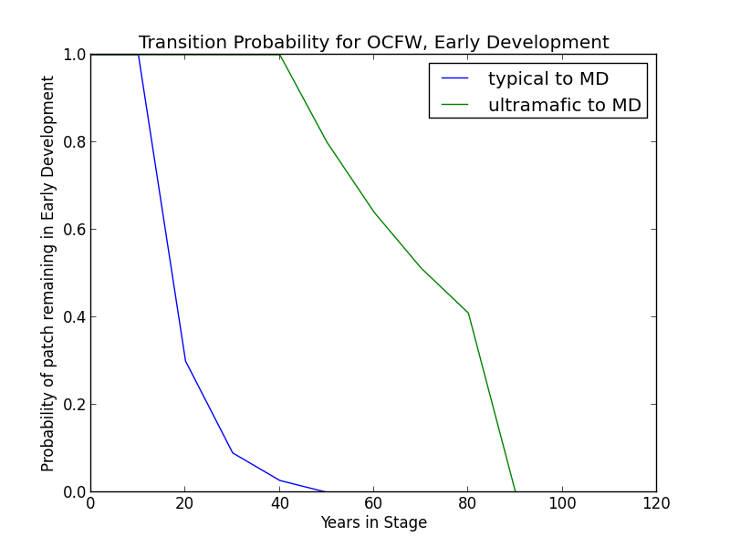**Succession Transition** In the absence of disturbance, this condition will begin transitioning to a mid development condition class after 20 years. The rate of succession per time step is 0.7. The transition may be to either MDC or MDO. The secondary rate of succession to MDO is 0.4 and to MDC is 0.6. At 50 years, all stands will have succeeded to either MDC or MDO.

* **Ultramafic Modifier** Succession may be substantially delayed. Thus, in the absence of disturbance, this condition will begin transitioning to MDO after 50 years and may be delayed in the ED condition class for as long as 100 years. A stand in this condition succeeds at a rate of 0.2 per time step.

**Wildfire Transition** High mortality wildfire (100% of fires in this condition) recycles the patch through the Early Development condition, regardless of soil type. Low mortality wildfire is not modeled for this condition.

### Mid Development - Open (MDO)

**Description** The mid-seral, open condition class has hardwoods dominating the canopy and may have sporadic conifer presence at low coverage levels. Oaks are pole-sized to very large. Bunchgrasses and shade-intolerant shrubs, most notably, will be prominent on the majority of sites. This condition is distinguished from MDC primarily by its reduced conifer presence (LandFire 2007a).

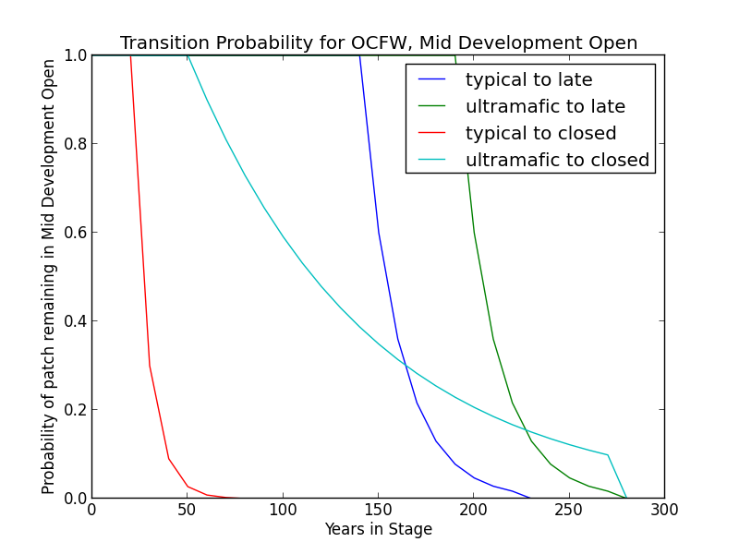**Succession Transition** This condition will maintain under low mortality disturbance, but after 30 years without fire it begins transitioning to MDC at a rate of 0.7 per timestep. After 150 years since transitioning to a mid development condition, succession to LDA occurs at a rate of 0.4 per timestep. All remaining stands transition after 230 years.

* **Ultramafic Modifier** In the absence of low mortality disturbance, patches will begin transitioning to MDC after 60 years at a rate of 10%. After 200 years in the mid development condition, succession to LDA occurs at a rate of 0.4 per timestep. All remaining stands transition after 280 years.

**Wildfire Transition** High mortality wildfire (4.3% of fires in this condition) recycles the patch through the ED-A condition. Low mortality wildfire (95.6%) maintains the patch in MDO.

* **Ultramafic Modifier** High mortality wildfire (5.6% of fires in this condition) recycles the patch through the ED-A condition. Low mortality wildfire (94.4%) maintains the patch in MDO.

### Mid Development - Closed (MDC)

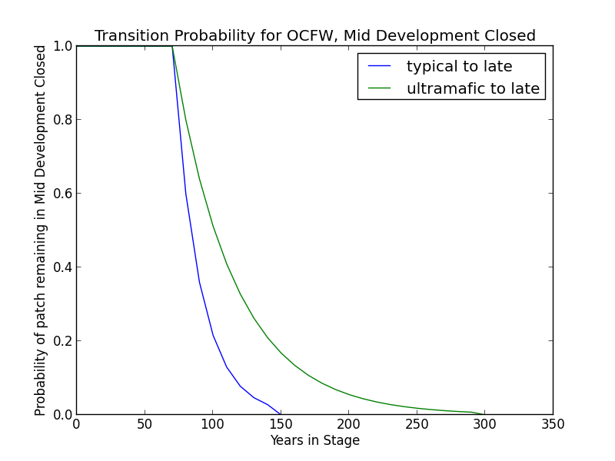**Description** The mid-seral, closed condition class is representative of the more mesic end of the environmental gradient and supports a dense canopy of oak and *P. ponderosa* and/or *P. menziesii*. Oaks are pole to medium sized with crown closure approaching 70%. Conifers are generally medium to large, depending on stand age. Overall canopy cover is at least 50%. Sod-forming grasses and shade-tolerant shrubs will be prominent on the majority of sites. Species from more arid sites may be remnants of earlier, more open post-fire communities. This condition is distinguished from MDO primarily by its support of greater numbers of conifer species (LandFire 2007a).

**Succession Transition** In the absence of disturbance, this condition will begin transitioning to LDA after 80 years in a mid development condition class at a rate of 0.4 per time step. After 150 years without disturbance, all remaining patches succeed to LDA.

* **Ultramafic Modifier** Transition to late seral conditions may be substatially delayed. Thus, in the absence of disturbance, this condition will begin transitioning to LDA after 80 years at a rate of 0.2 per time step and may be delayed in a mid development condition for up to 300 years.

**Wildfire Transition** High mortality wildfire (4.7% of fires in this condition) recycles the patch through the ED-A condition. Low mortality wildfire (95.3%) triggers a transition to MDO 12.7% of the time; otherwise the patch remains in MDC.

* **Ultramafic Modifier** High mortality wildfire (5.3% of fires in this condition) recycles the patch through the ED-A condition. Low mortality wildfire (94.7%) maintains the patch in MDC 30% of the time; otherwise, the patch opens up to the MDO condition.

### Late Development - All (LDA)

**Description** The late-seral condition occurs when fire has been excluded from a patch for an extended period of time. Oaks are being overtopped by conifers, especially shade-tolerant conifers such as *P. menziesii*. Thus, in this condition, oaks and even pines comprise a smaller proportion of the stand. Oaks and conifers are mature and large (LandFire 2007a). In general, sites that have reached LDA are relatively open (Estes 2013).

**Succession Transition** In the absence of transition-causing disturbance, this condition will maintain.

**Wildfire Transition** High mortality wildfire (5% of fires in this condition) recycles the patch through the early development condition. Low mortality wildfire (95%) maintains the patch in LDA.

* **Ultramafic Modifier** High mortality wildfire (5% of fires in this condition) recycles the patch through the ED-A condition. Low mortality wildfire (95%) maintains the patch in LDA.

**Condition Classification**

Table 2. Classification of cover condition for OCFW. Diameter at Breast Height (DBH) and Cover From Above (CFA) values taken from EVeg polygons. DBH categories are: null, 0-0.9”, 1-4.9”, 5-9.9”, 10-19.9”, 20-29.9”, 30”+. CFA categories are null, 0-10%, 10-20%, … , 90-100%. Each row in the table below should be read with a boolean AND across each column of a row.

|  |  |  |  |  |  |
| --- | --- | --- | --- | --- | --- |
| Cover Condition | Overstory Tree  Diameter 1 (DBH) | Overstory Tree  Diameter 2 (DBH) | Total Tree  CFA (%) | Conifer  CFA (%) | Hardwood  CFA (%) |
| Early All | null | null | any | any | any |
| Early All | 0-4.9” | 0-4.9” | any | any | any |
| Early All | 0-4.9” | null | any | any | any |
| Mid Open | 0-4.9” | 5-29.9” | <50 | any | any |
| Mid Open | 5-29.9” | null | <50 | any | any |
| Mid Open | 5-29.9” | null | null | <50 | any |
| Mid Open | 5-29.9” | null | null | null | <70 |
| Mid Open | 5-29.9” | 0-29.9” | <50 | any | any |
| Mid Open | 5-29.9” | 0-29.9” | null | <50 | <70 |
| Mid Closed | 0-4.9” | 5-29.9” | >50 | any | any |
| Mid Closed | 5-29.9” | null | >50 | any | any |
| Mid Closed | 5-29.9” | null | null | >50 | any |
| Mid Closed | 5-29.9” | null | null | any | >70 |
| Mid Closed | 5-29.9” | 0-29.9” | >50 | any | any |
| Mid Closed | 5-29.9” | 0-29.9” | null | >50 | any |
| Mid Closed | 5-29.9” | 0-29.9” | null | any | >70 |
| Late All | 30”+ | any | any | any | any |
| Late All | any | 30”+ | any | any | any |

**Draft Model**

(See PDF) Disturbance-Succession model for OCFW.

**References**

Anderson, Richard. “Montane Hardwood-Conifer (MHC).” *A Guide to Wildlife Habitats of California*, edited by Kenneth E. Mayer and William F. Laudenslayer. California Deparment of Fish and Game, 1988. <http://www.dfg.ca.gov/biogeodata/cwhr/pdfs/MHC.pdf>. Accessed 4 December 2012.

Barrett, S., D. Havlina, J. Jones, W. Hann, C. Frame, D. Hamilton, K. Schon, T. Demeo, L. Hutter, and J. Menakis. *Interagency Fire Regime Condition Class Guidebook*. Version 3.0. USDA Forest Service, US Department of the Interior, and The Nature Conservancy, 2010. <http://www.frcc.gov>. Accessed 5 June 2013.

“CalVeg Zone 1.” Vegetation Descriptions. *Vegetation Classification and Mapping*. 11 December 2008. U.S. Forest Service. <http://www.fs.usda.gov/Internet/FSE_DOCUMENTS/fsbdev3_046448.pdf>. Accessed 2 April 2013.

Estes, Becky L. Personal communication, 21 June 2013.

Fitzhugh, E. Lee. “Ponderosa Pine (PPN).” *A Guide to Wildlife Habitats of California*, edited by Kenneth E. Mayer and William F. Laudenslayer. California Deparment of Fish and Game, 1988. <http://www.dfg.ca.gov/biogeodata/cwhr/pdfs/PPN.pdf>. Accessed 4 December 2012.

Fryer, Janet L. “Quercus kelloggii.” *Fire Effects Information System*, U.S. Department of Agriculture, Forest Service, Rocky Mountain Research Station, Fire Sciences Laboratory, 2007. <http://www.fs.fed.us/database/feis/plants/tree/quekel/all.html>. Accessed 21 December 2012.

LandFire. “Biophysical Setting Models.” Biophysical Setting 0610300: Mediterranean California Lower Montane Black Oak-Conifer Forest and Woodland. 2007a. LANDFIRE Project, U.S. Department of Agriculture, Forest Service; U.S. Department of the Interior. <http://www.landfire.gov/national_veg_models_op2.php>. Accessed 9 November 2012.

LandFire. “Biophysical Setting Models.” Biophysical Setting 0610210: Klamath-Siskiyou Lower Montane Serpentine Mixed Conifer Woodland. 2007b. LANDFIRE Project, U.S. Department of Agriculture, Forest Service; U.S. Department of the Interior. <http://www.landfire.gov/national_veg_models_op2.php>. Accessed 9 November 2012.

LandFire. “Biophysical Setting Models.” Biophysical Setting 0711700: Klamath-Siskiyou Xeromorphic Serpentine Savanna and Chaparral. 2007c. LANDFIRE Project, U.S. Department of Agriculture, Forest Service; U.S. Department of the Interior. <http://www.landfire.gov/national_veg_models_op2.php>. Accessed 30 November 2012.

O’Geen, Anthony T., Randy A. Dahlgren, and Daniel Sanchez-Mata. “California Soils and Examples of Ultramafic Vegetation.” In *Terrestrial Vegetation of California, 3rd Edition*, edited by Michael Barbour, Todd Keeler-Wolf, and Allan A. Schoenherr, 71-106. Berkeley and Los Angeles: University of California Press, 2007.

Skinner, Carl N. and Chi-Ru Chang. “Fire Regimes, Past and Present.” *Sierra Nevada Ecosystem Project: Final report to Congress, vol. II, Assessments and scientific basis for management options*. Davis: University of California, Centers for Water and Wildland Resources, 1996.

Van de Water, Kip M. and Hugh D. Safford. “A Summary of Fire Frequency Estimates for California Vegetation Before Euro-American Settlement.” *Fire Ecology* 7.3 (2011): 26-57. doi: 10.4996/fireecology.0703026.